**Ch 8 – The IO Library**

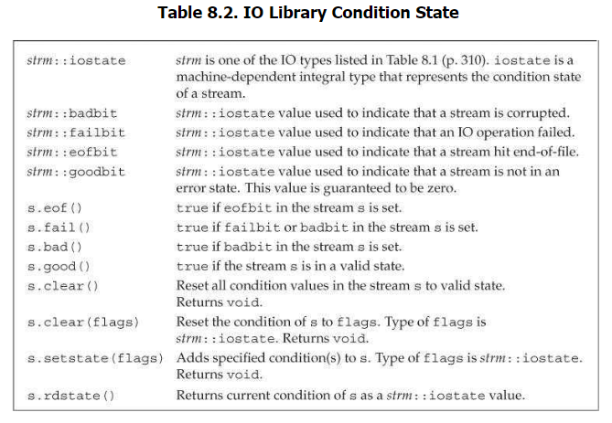

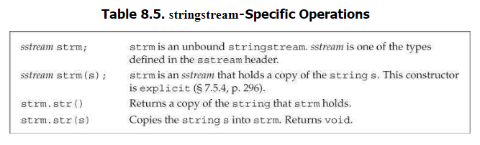

**Ch 9 – Sequential Containers**

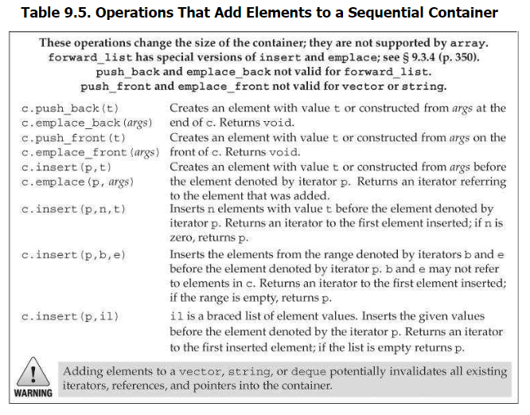

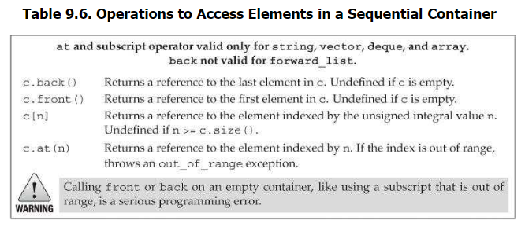

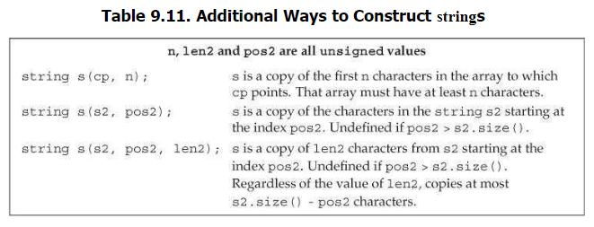

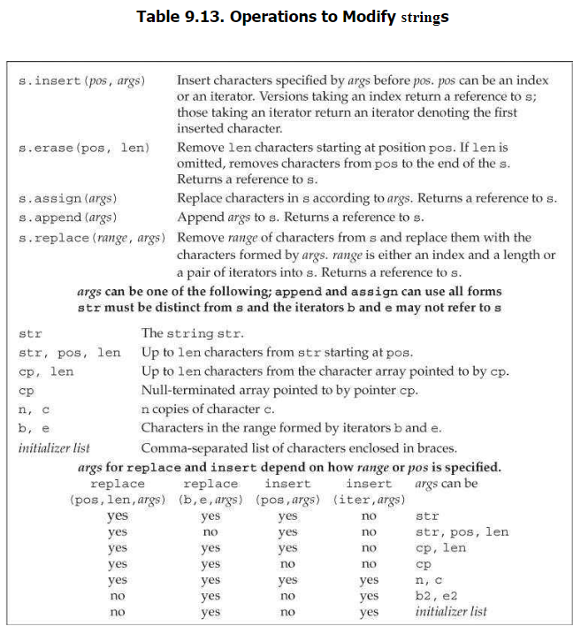

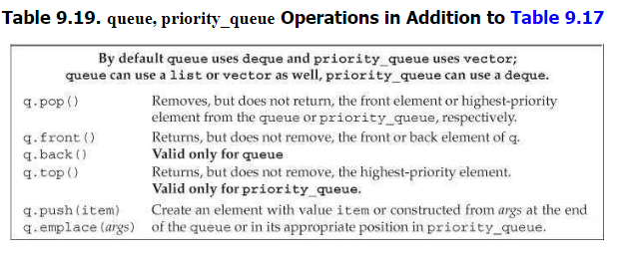

**Ch 10 – Generic Algorithms**

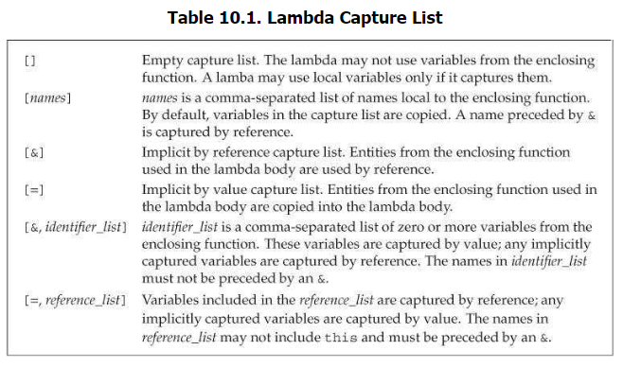

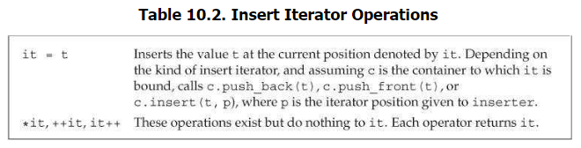

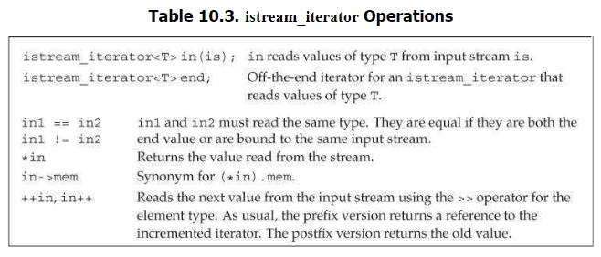

**Ch 11 – Associative Containers**

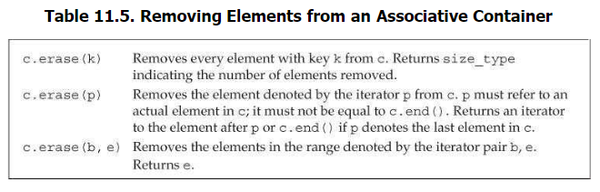

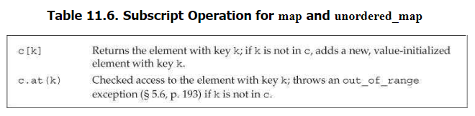

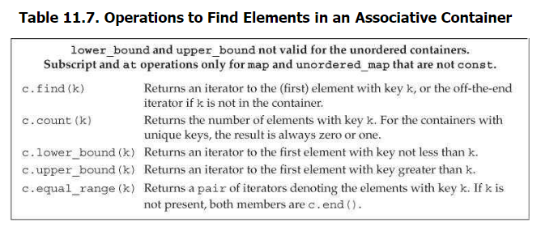

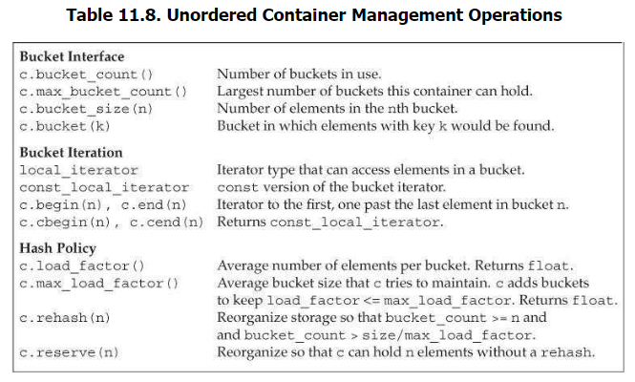

**Ch 12 – Dynamic Memory**

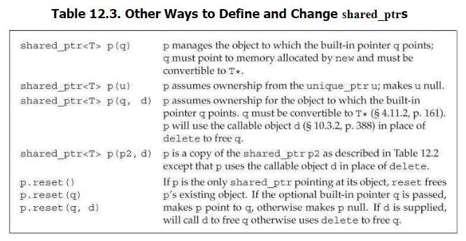

**Ch 13 – Copy Control**

N/A

**Ch 14 – Overloaded Operations and Conversions**

**Ch 15 – Object Oriented Programming**

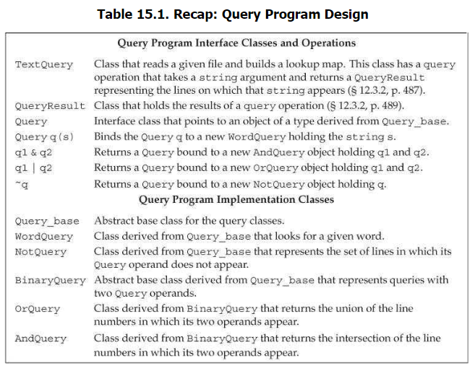

**Ch 16 – Templates and Generic Programming**

